4th Edition Future Landscape & Playspaces UAE Summit
Date: 29–30 April 2026
Location: Dusit Thani Dubai, UAE
My Experience
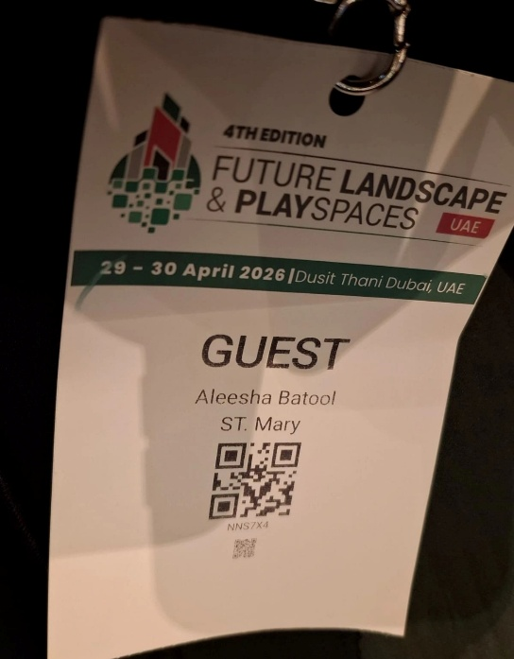
Unlike many technology-focused conferences that I have attended this one offered a completely different perspective on innovation. Rather than focusing on software, cybersecurity, or artificial intelligence alone I got to explore how cities, public spaces, and natural environments can be designed to improve quality of life. The summit brought together urban planners, landscape architects, developers, sustainability experts and lots of technology innovators to discuss the future of urban living in the UAE.
Walking into the summit, I initially expected discussions centered mainly on parks and landscaping but realized that modern landscapes involve much more than planting trees or creating green spaces, exploring how thoughtful urban design influences sustainability, public health, community well-being, cultural identity, and even economic growth.

Key Learnings
- Sustainability Must Be Integrated Into Urban Development: One of the strongest messages throughout the summit was that sustainability should not be treated as an afterthought. Instead, environmental considerations need to be integrated into every stage of planning and development. From water conservation to climate-resilient planting strategies.

- Green Spaces Create Real Economic and Social Value: Before attending the summit, I mainly viewed parks and landscapes as recreational spaces. However, many speakers demonstrated how high-quality public spaces contribute to property value, tourism, public health, and overall community satisfaction. Landscapes are investments that generate long-term benefits rather than simply aesthetic additions.

- Technology Is Transforming Landscape Management: A particularly interesting topic was the use of AI, geospatial technologies, smart irrigation systems, and data-driven decision-making in modern landscaping. These tools allow cities to manage resources more efficiently while reducing waste and improving environmental performance.

- Human Well-Being Depends on Thoughtful Design: The discussions on playspaces and public realm development highlighted how urban environments influence mental health, social interaction, physical activity, and childhood development. Well-designed public spaces can encourage stronger communities and healthier lifestyles.

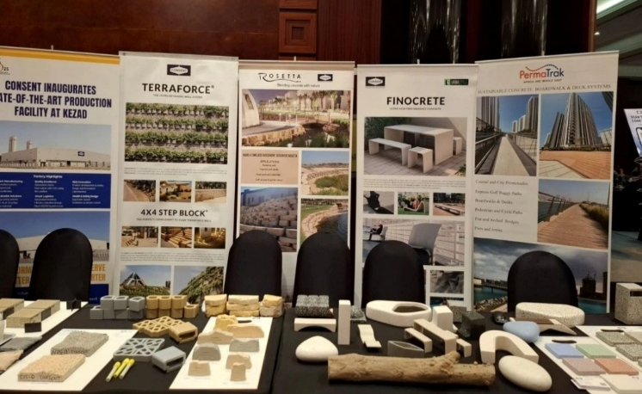
Beyond the keynote sessions, the exhibition area gave me a chance to see products and technologies that are used in today’s landscape projects. One display that really stood out had materials for public areas like eco-friendly boardwalks, creative concrete options that look like nature movable green walls and city furniture designs.
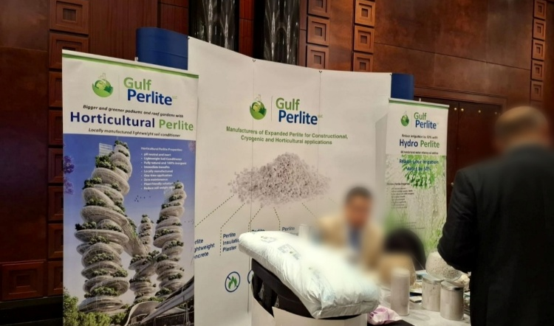
Being able to touch and see the samples instead of just looking at pictures on slides made me understand how complicated it is to make public spaces that work well and are good for the environment. The exhibition showed how science, building skills and landscape design come together to turn ideas into places, in the city.

Speakers
The event brought together professionals from government authorities, municipalities, urban planning organizations, consulting firms, architecture practices, engineering companies, and development firms.
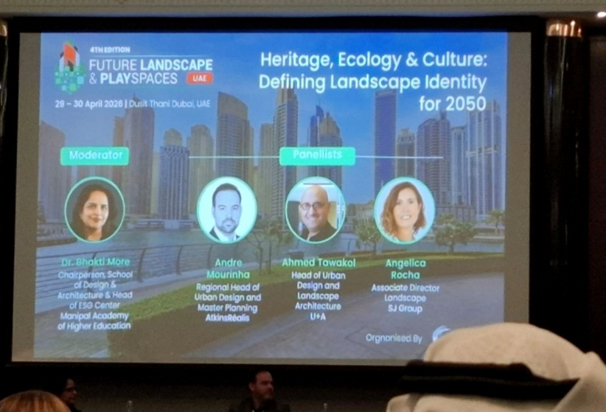
It was impressive seeing how multiple disciplines intersect to shape the places where people live, work, and socialize. Speakers discussed ambitious projects connected to Dubai's Public Parks and Greenery Strategy and broader efforts across the UAE to create more sustainable and livable cities
The summit also introduced me to concepts I had rarely explored before, such as climate-responsive landscape design, regenerative tourism, biodiversity enhancement, and child-centered playspaces. Listening to industry professionals explain how these ideas are applied in real projects helped me understand the complexity of creating spaces that are both environmentally responsible and enjoyable for people.

Inspiration and Future Ideas
While my academic interests are mostly in computer science and AI going to this summit opened my eyes. I saw how technology, sustainability and urban planning all fit together and the way they help shape what future cities will be, like.
I also did come up with some Ideas! such as:
- A Python-based tool that analyzes environmental data (temperature, rainfall, soil conditions) and then recommend suitable plant species for different locations.
- Investigating how AI can optimize irrigation schedules to reduce water consumption while maintaining healthy green spaces.
- Looking more into geospatial mapping technologies to better understand urban development patterns and environmental impacts.

